LEAD4innovation (Learning Evaluation And Design)Toolkit
A toolkit for small-scale media and communication projects in the Pacific

Module 1: Introduction to the Learning, Evaluation and Design for innovation (LEAD4innovation) toolkit

This draft toolkit is intended to support small-grant recipients use a learning-based approach to planning and managing evaluation. Taking a learning-based approach means you need to think about evaluation as you design projects; we believe this will, in turn, lead to improved project design and better and more useful evaluation. Focusing on learning is especially important when the project idea is new and innovative.

This toolkit has been developed with the contributions of C4D practitioners in the Pacific, and in particular in the context of the PACMAS Innovation Fund activities. The Innovation Fund offers small-grants for new and innovative projects using media and communication to people and groups located across the Pacific region. PACMAS encouraged applications from people and organisations with little or no experience of developing such activities projects as a way of fostering grassroots participation and innovation. This type of funding is exciting and full of potential, however, the experience of the activities demonstrated the importance of building in capacity development for grantees as part of the overall program. Additionally, through the research with C4D practitioners we identified a need to develop appropriate evaluation tools; evaluation approaches must be proportionate to the size of the grant, draw on culturally appropriate approaches, and be accessible for those new to project management and evaluation.

This toolkit capitalizes on the knowledge built up by all those involved in the PACMAS Innovation Fund program: from the managing organization (ABC ID), the PACMAS project team, and in particular the recipients of the funds.

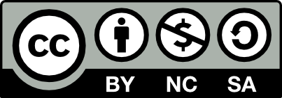
We publish this toolkit under the Attribution-NonCommercial-ShareAlike 4.0
license. We encourage you to use and remix this toolkit to suit your needs. We simply ask that you attribute the source and provide the same licence conditions in your products. If you do use this content please share your experiences with us so this can be included in ongoing research into C4D Evaluation.

Principles for evaluating media, communication and development
Evaluating communication projects is often challenging, especially when you are trying something new or innovative. Outcomes and results may be indirect and unpredictable. Project plans often need to change because of changing situations. Learning and adapting the project design as the project is implemented is very important. The Evaluating Communication for Development Framework by Lennie and Tacchi (2013) supports learning-based evaluation that suits communication projects by suggesting seven key principles. Hints and reminders of the principles and why they are important at the relevant stages are included throughout the toolkit, using the symbols from the diagram below.

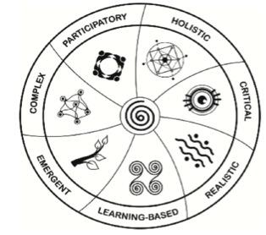

1) being participatory means involving and listening to your stakeholders, and this can improve the project outcomes and sustainability;
2) thinking holistically means taking being aware of the whole context in which a project is working, including the cultural, political, social, economic and technological aspects;
3) allowing for complexity means that we remember that changes are often unpredictable and to try to understand the different ways projects contribute to changes (rather than expecting to cause change);
4) being critical means being aware of power and difference (such as age, gender, status) and trying to make sure different perspectives and experiences are included;
5) having an emergent project design and evaluation approach means being flexible and adapting to changing situations and understandings;
6) being realistic means considering the needs, resources and capacities of all involved in your project;
7) using a learning-based approach means using insights and information throughout the project to continually improve the project.

Overview of the toolkit
What is this toolkit for?
This toolkit is for organisations and people who are doing small, media and communication projects. It guides you through the process of designing a project, and thinking about the evaluation. The toolkit is focused on how to do useful evaluation for learning and continual project improvement. To achieve this it is important to think about the evaluation of the project as you design it, and to learn from evaluation during the implementation of the project. Focusing on learning is especially important when the project idea is new and innovative.

Why was it developed?
This toolkit was developed in the context of the PACMAS Innovation Fund programme. The Innovation Fund offers small-grants for new and innovative projects using media and communication to people and groups located across the Pacific region. PACMAS encouraged applications from people and organisations with little or no experience of developing projects as a way of fostering grassroots participation and innovation. This type of funding is exciting and full of potential, however, the experience of the program demonstrated the importance of building in capacity development for project teams as part of the overall program. In addition, project teams wanted design and evaluation tools that were realistic for small-scale projects, that are sensitive to culture, and that are simple to understand and use.

How should I use this guide?
This toolkit has been developed with the idea that a funding organization could play an active role in helping project teams to use the toolkit. This facilitation role is important to help talk through the options, and how to adapt the activities to the project situation. However, it is also possible to use the toolkit independently if this is the only option. There are 8 modules in the toolkit. Each module includes an explanation of the module, some guided steps and some discussion questions for the project team. Often there are links to websites and other resources if you need further information.

Structure of the toolkit
The LEAD4innovation toolkit is divided into 8 modules. Although the sequence of these activities may work in many cases, you can adapt the order to suit your purposes.
Toolkit Module | Objectives and Activities
Module 1: Introduction | Introduction to the toolkit and how it helps when designing, evaluating and learning about small-scale communication projects.
Module 2: Define | What are we trying to do, how are we trying to do it?
Module 3: Engaging with Stakeholders | Who has an interest or role in our project design and evaluation? How can we communicate with them?
Module 4: Ethics | What are the potentially ethical issues in media and communication projects and evaluation? How can we prevent these from becoming problems?
Module 5: Planning Data Use | What is our overall timeline for sharing our findings and insights? How can we build-in continuous learning? What are the most appropriate ways to share our insights?
Module 6: Ask Questions | Based on our main goals, what are our key evaluation questions?
Module 7: Planning Information and Data Collection  Module 8: Making Sense of Data | Which data collection methods will give us the best information to answer our questions? Which methods are realistic?  How do we manage our data? How can we make sense of and analyse different kinds of data?
Facilitator’s Guide (separate) | Helps the facilitating organizations synthesise across groups of projects

Discussion exercise:
Discuss the 7 key principles listed above, and reflect on the following questions:
- in what ways are these principles important to your work?
- in what ways do you currently incorporate them?
- do you work with any other key principles? what are they?
- would you like to find ways to follow any of the principles more thoroughly in your work?
This toolkit will help you to design your evaluation according to these 7 principles. Look for the relevant symbols throughout the toolkit.

Module 2: Define the idea
What are we trying to do, how are we trying to do it?
Holistic: Successful and sustainable C4D projects are designed with an understanding of the local communication context (or communicative ecology) and other social, cultural, economic, technological, organizational and institutional systems and contexts.

This module includes series of steps and tools to help you identify what you are trying to do, and how you are trying to do it. Where possible, this is best completed as a group activity with your whole team.

Step 1: What are you trying to do?

Discussion exercise
A good place to start is to think about what success would look like. Start by thinking about the current situation. What is the problem you are trying to solve? Now try to imagine the future – if you project is successful how is the future different to the present in one year? in five years? You might like to draw and write a story about what success for your project means. You can use the space below or do this separately.

Step 2: How are you trying to do it?
This tool is designed to help you visualize how you are trying to achieve your goals. There is also a digital version of this task that uses Microsoft Excel.

Group exercise
Look at the statements below. On a scale of 0-10 where 0 is not at all true and 10 is very true, add a score in the box provided. Add up the scores for each section then cut out the circle that represents that score. As a group you will then compare the sizes of the circles for each section to get a sense of the most significant aspects for your project.
Content
We will be creating engaging content (film, radio, poster, website, mobile content, theatre)
We will create content that increases people’s knowledge and understanding on a particular issue or topic.
We will create opportunities for people to view/hear/read the content we make
Total

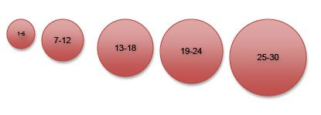
Dialogue
We will encourage people to discuss issues that are important to them and decide how they want to address those issues
We will help decision makers and other people in power to hear what communities want
We will create/mediate opportunities for different people to come together in dialogue
Total

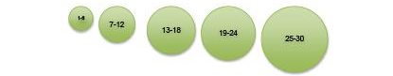

Capacity Building
We will focus on improving the skills of people (e.g. journalists, bloggers, community members, health workers, others)
We will provide training or mentoring
We will be building networks and connections
Total

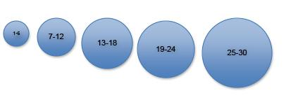

Infrastructure
We will improve the quality of content or communication through providing equipment or infrastructure
We will improve the systems through which people make and receive content or information
We will work to change or improve the policies, laws and regulations relating to media and communication
Total

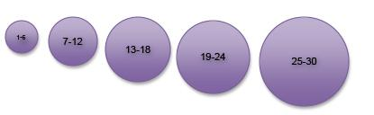

Module 3: Engaging with the people connected with the project (stakeholders)
Participatory: Local participants and experts often all have experiences and knowledge about your project that will be useful for learning and evaluating. How can you involve all kinds of stakeholders in the design and evaluation process?
Stakeholders are people or organizations who are in some way involved in the project. These may be people who can help to create change, or who may be affected by the changes. You may depend on the active participation of these people for your project to successfully bring about the changes you want to create. Identifying your stakeholders and thinking about how you can do your best to involve them is therefore very important.

Stakeholder Mapping Group Exercise:
Stakeholder mapping can help you identify stakeholders, their interests in the project and its evaluation. From there you can think about how to encourage their active participation. Who has an interest in, or is affected by, what you are doing and how you are doing it? In later modules we’ll refer back to this map to consider the project design and evaluation from different perspectives.

We outline two options: one is useful if you have access to sticky-notes, the other is an option for drawing on paper.
This activity is best done in groups involving your project team.
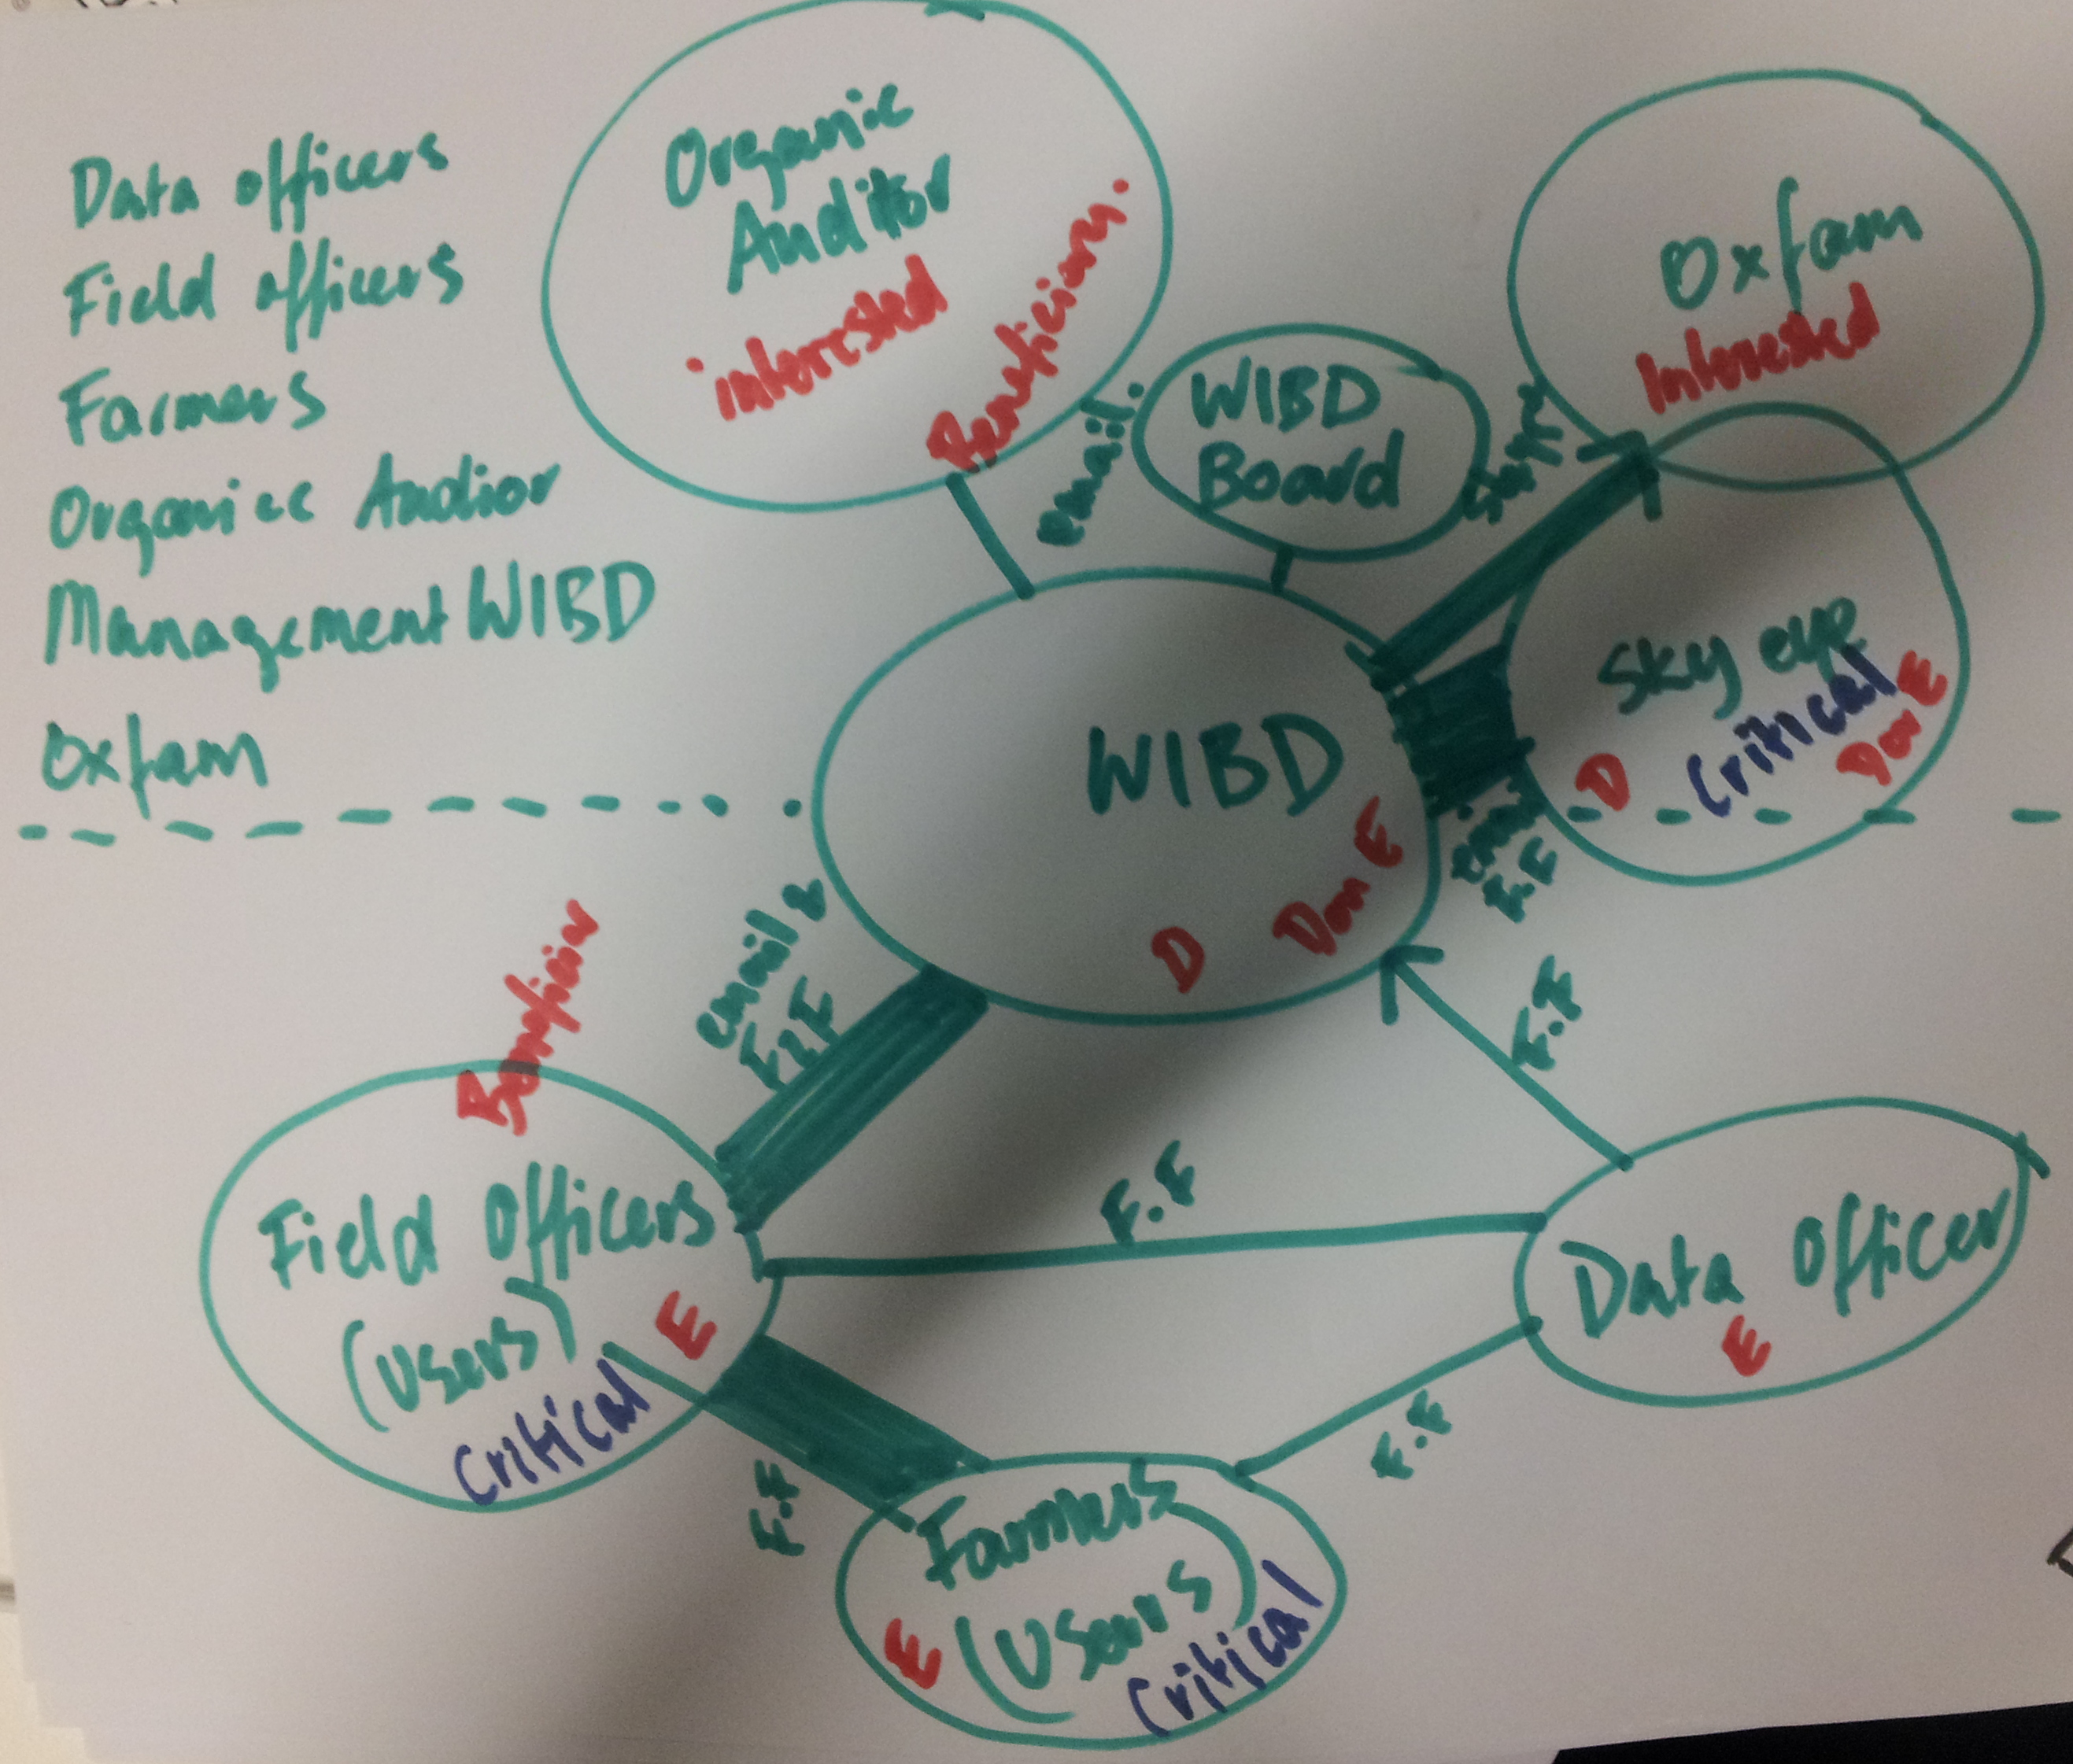
Figure 0.1 Example of stakeholder map for a project in Samoa
Option A:  Materials: Sticky-notes, textas, flipchart paper, camera  - Write the name of each of your of stakeholders (people or groups/organisations) on sticky notes. Your stakeholders could include specific communities, village chiefs, specific people or groups within communities, volunteers, funders, employees of organisations, project staff, senior leadership, ‘experts’, government officials or others.  - Experiment with how to represent your stakeholders.  - Can you arrange the sticky-notes with your stakeholders into categories? Are there any others ways you can group or categorise your stakeholders in different ways? Take a photo of these different arrangements, and make a note about what you discussed.  - Write the name of your project in the middle and arrange the stakeholders around the project, moving the stakeholders most connected to the project close to the middle, and those most distant further away. | Option B:  Materials: paper (ideally flip-chart paper), textas or pens, camera  - Make a list of all the stakeholders (people or groups/organisations) on sticky notes. Your stakeholders could include specific communities, village chiefs, specific people or groups within communities, volunteers, funders, employees of organisations, project staff, senior leadership, ‘experts’, government officials or others.  - Now draw a map of these stakeholders and how they relate. We suggest the following:  - write the name of the project in the middle of the paper.  - add the names of stakeholders, using the distance from the project in the middle to represent how close or distant the relationship is  - circle each stakeholder, using a big circle to represent key stakeholders, and small circles to represent less critical stakeholders (see the example picture above.  - draw lines to link the stakeholders to the project, or stakeholders to other stakeholders

Option A&B continue...
3. Indicate each stakeholder's interest in the project, that is, how the stakeholder might benefit from the project. Each stakeholder may have several interests.
  - Has a critical role in making the project a success; or
  - Is interested in the project;
  - Knows about the project but is not committed to it; or
  - Has a vested interest in disrupting the project, that is, competitors, etc.

4. Identify each stakeholder's possible role in the project design and evaluation, that is, whether the stakeholder can:
  - Participate in decisions about the project
  - Provide feedback and information for the evaluation
  - make a decision based on the findings of the evaluation; or
  - become a beneficiary of change arising from the (evaluation), etc.

Communicating with your stakeholders
Effective communication with all stakeholders is a vital element of a participatory approach. It is likely to help project success and learning. It is important to start planning how you will communicate, with whom, when and why early in your project. Communication implies dialogue and is two-way, not simply about sending information. This requires creating opportunities for both speaking and listening, for all of your stakeholder groups.

Group Exercise:
- Draw a thick line between the project and the stakeholders where you communicate well and regularly (or need to), and draw a thin line where you communicate less often and less openly.
- How you will communicate with them. This may change throughout the project. Think about:
  - What are the best ways for us to communicate? (Skype, email, phone, meetings, face-to-face)
  - What are the potential barriers to continuous, two-way communication?
  - What are the most effective and appropriate ways to share results with different stakeholder groups. For example: summary sheets? meetings? presentations and talks? videos? Post cards (see ‘Learn and Share’ section)
  - What are the reporting requirements? What is the most appropriate form for these to be presented?

Keep your map as you may use this in later activities in this toolkit. You may also take a photo of your map as a record and to easily share with others.
Step 3: How are you engaging your stakeholders in the design and evaluation?

Discussion Exercise
Look at your stakeholder map and think about how you engage with your stakeholders and different kinds of expertise. In your teams, discuss the following:
- Who is contributing to the decisions you make?
- Who is influencing your ideas and plans?
- Who is giving feedback on your outcomes?

Step 4: Visualise your approach

Group Exercise
The grid on the next page will help you to visualise these relationships. Place the cut-out circles from the Module 2 in the box that best describes the relationships and decision-making processes in your project in terms of how ‘top down’ or ‘bottom up’ they are.

Very top- down | Content  Outsiders with expertise will influence/ contribute to the creation or distribution of content | Dialogue  Outsiders with expertise will influence topics and outcomes of discussions | Capacity  Outsiders with expertise will provide training/ mentoring/build networks (or we are using pre-existing training packages) | Infrastructure Outsiders with expertise will influence or contribute to planning & implementation of infrastructure
Mainly top-down

Mixed but more top down than bottom up

Mixed but more bottom up than top-down

Mainly bottom up

Very Bottom up | Content  The participating group/community will influence/ contribute to the creation or distribution of content | Dialogue  The participating group/community will influence topics and outcomes of discussions | Capacity  The participating group/community will provide or influence training/ mentoring/build networks | Infrastructure  The participating group/community will influence or contribute to planning & implementation of infrastructure

This grid now gives you an idea of what the components of media, communication and development approaches are most relevant to your project, and the kinds of ways you are engaging with stakeholders and communities.

Discussion Exercise: in your team discuss the following:

- Does the amount of focus on each component seem right to you?
- Does the positioning in relation to top down and bottom up approaches seem right to you?
- Would you like to adjust this? If yes, how will you change your project and your approach and what will be the benefit?
- Do you need to link other kinds of expertise into the design of your project?

After discussing these questions with your teams, revise your responses to questions and make relevant changes to the grid. Remember to keep track of any decisions that influence how you plan and implement the project.

If your vision about what you are trying to do (your goal) has changed, write the revised statement below:

Keep this visual representation and your vision/goal for the later modules, as it will help you determine how you evaluate success against your goals.

Module 4: Ethics (doing the right thing by people involved in the project)
Critical: what are the differences in age, gender, language, education, community group, community status that might lead to differences in power and confidence to speak? Awareness of these differences help you choose the best approach.
It is very important that you think about how you can be ethical in your C4D projects and your evaluations of these projects.

Important things to discuss with project participants
- What do you want people involved in your project to do?
- What you will do with people’s stories?
- Who will see the stories? Who will have access to the stories?
- Can they see what you will do with their stories?
- What can they expect will happen after they participate?
- Could anything bad happen?
- Is it possible that nothing will happen?

Ways to talk to participants about being part of the project
You could do one or more of the following, or add your own:
- Ask people to read information
- Hold a community meeting and explain the project and invite questions
- Talk to the chief about the project
- Explain the project before every interview or activity
- (add others here)

Evaluation ethics: extra things to think about
Ethics is more than just ticking boxes, it is important to think about:
- What is the culturally appropriate way to ask people for their feedback and observations about the project?
- What can you do to help people to feel comfortable to give open feedback (for example in workshops, in in questionnaires? in a group setting? in a one-to-one setting)
- Will you ask people’s names on surveys or questionnaires?
- Will you use people’s names when you use things they say in reports? What is the best way to explain this?

Module 5: Planning data-use
Data is all of the facts and information collected for the evaluation. It can include interview recordings and transcripts, questionnaire results, notes, photographs etc. It is good to think about who will use your evaluation data, when they will use it and how early in your project. There is no point collecting data unless it has a purpose. The data that you collect and analysis will have different uses for different stakeholders. For example, you may need to provide reports to the fund managers, and you may want to share reports with the communities you work with. The data should also be useful for you to think about how you can improve the project.

Data-use Calendar
If you don’t already have a team or project calendar you could create one using google calendars, or download a printable calendar (e.g. http://www.calendarlabs.com/printable-calendar.php). Creating or adding the Data-Use activities to your project calendar at the beginning of the project helps to make sure that everyone understands the expectations for reporting. It also can be used to plan for when and how you will sit down as a team to think about what the data means, and how you could improve project.

Steps
1. Add all of the activities you have planned to the calendar
2. Add all of the times when you expect to collect data to the calendar
3. Find out when you may have meetings or visits with your stakeholders and/or when you need to report to your fund managers (see the Learn and Share section to get an idea of the ways you might report). Add this to the calendar.
4. List all the existing opportunities you have to meet with your team. For example, do you have regular team meetings? Add these to your calendar.
5. Now look at the gaps – do you have enough time and opportunities to analyze data between data collection and reporting to your stakeholders? Do you have enough time between activities to be able to use what you have learnt in the next stages?
When you have completed your Data-Use calendar send it to your Fund Managers and discuss your plans with them.

Learning from data: the ‘Learning Loop’
Learning Based: Evaluations should be focused on being useful and supporting learning. Learning depends on good communication, cooperation, collaboration and trust between all those involved.

To make the most of your evaluation it is important that you are able to learn from it, make improvements and share your findings with others. This kind of learning can also help you gain funding for similar or related activities in the future, as you will be able to demonstrate need or previous successes. It is a good idea to include discussions of your evaluations into your existing meetings. You can also look at your data-use calendar and set meetings for when you can discuss the data and think about project learnings and improvements.
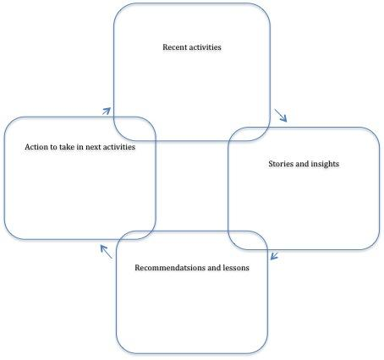
The tool below is something that you can use to guide your thinking and discussions. Begin by listing the recent activities (for example: planning activities, meetings with different people etc.) then list the most significant insights and stories, then consider what the recommendations from this are. Make some notes in the diagram and keep it for when you repeat the process at the next meeting so that the learning loop continues.

Planning how to share your findings
Project Postcard!  We have just finished  We are currently working on Highlights  Insights  Next steps | [place photo here, or attach video/audio]  [Caption]
Most people think of text-based reports when they think about how to share their findings. These kinds of reports are fine if you and your stakeholders are most comfortable with this way of communicating, but there are other alternatives that might help you to include richer information in ways that are more accessible to your stakeholders. You might need to use different kinds of reporting methods for different stakeholders, but try not to commit to too many! Refer back to your stakeholder map and the modes of communication you identified in the Stakeholder Mapping section (Module 2) when you think about who you want to report to. Add your plans for sharing findings to your data-use calendar, making sure to allow time for preparing the reporting materials.

OPTIONS
Regular progress reporting via multi-media project postcards
Postcards are a great way to maintain regular communication throughout the project. These would usually be sent by email. You can add a photo, send video, and add some text.

Written Reports
Check with the fund managers to see if they have headings they would like you to use.

Photography
Take and assemble photographs of the key moments in your project and the changes or results you consider are significant. Write or record a narrative to go with the photo

Video
If you are already competent with making videos you could consider make a video report to show funders, managers and the community. Make sure it covers the things the stakeholders want to know. You can include parts of interviews (with the person’s permission) videos of the activities, video of the area.

Module 6: Ask Questions
Emergent: Remember that projects often need to change (due to changes in priorities, new information). It is a good idea to return to this exercise throughout the project to see if you have new questions or different priorities.

Identifying appropriate and useful evaluation questions is often one of the most challenging parts of designing an evaluation.

Uses and Users of evaluation
Discussion Exercise:
To identify the intended users and uses of the evaluation go back to the Stakeholder Map.
- Which stakeholders who might want to use the evaluation.
- What will they use it for?
- Should they be involved in identifying the key questions?
- If so, how will you involve them? Will you inform them (tell them your decision), consult with them (ask them for their comments and feedback), or collaborate with them (work as equal partners to make decisions)?

Specify the key evaluation questions.
It is important that the questions match the project design and answer questions that will be useful for all the stakeholders. Based on your design visualization in the previous module, some colour coded common evaluation questions are provided here for you to adapt.

Content

Dialogue
Capacity Building
Infrastructure

Common Evaluation Questions in C4D small grant projects
Content
Who has seen the content? How many people have seen the content?
What did they understand or learn about the topic? How did communities and others use the content?
Did the content have high production values, and in what ways was that important/unimportant to viewers/users?
In what ways was the content engaging?
In what ways was the content culturally relevant?
How does the content produced reflect the participatory process?
Dialogue
In what ways did project participants participate in regular discussions with each other and the team leader.
Who took part in the dialogue opportunities you set up and what has happened as a result of the dialogue?
Were safe spaces created for community members to discuss sensitive topics, and how did they respond?
What kind of feedback did project participants provide and was the feedback integrated into the design of the project?
To what extent are communities more willing or able to use opportunities to engage with and question leaders and decision makers?
To what extent are leaders more willing or able to hear communities, and respond to their ideas and concerns?
Capacity Building
Who took part in training or mentoring processes, and how did they benefit?
In what ways have the skills of participants improved?
How did they put their new skills into practice?
In what ways are people using the networks and connections you established?
How relevant were the skills or networks that you have built?
Are participants interested in further training?
Have participants expressed interest in using their skills for future projects.
Infrastructure
How have people used and benefited from the equipment or infrastructure you set up?
How have people used and benefited from the systems you set up to help them make and receive content?
What kind of plans are there for support and maintenance for systems and equipment?
Have there been changes or improvements in the policies, laws and regulations relating to media and communication?

Group Exercise

- After reading the list of common types of evaluation questions in C4D, and looking at where you have plotted your project, can you find the types of questions that relate to projects like yours?
- Using these questions as a guide, adapt the questions or develop new ones relevant to your project. Write these questions on post it notes or cut up pieces of paper into cards.
- Arrange the cards or post-it notes in order of the most useful to the least useful questions. If you can, ask your stakeholders who may be interested in using the evaluation to do the same, and compare the results. If this isn’t possible, try to imagine the perspectives of each stakeholder on your list, rearrange the priorities according to their interests and uses for the evaluation and compare the results.
- Now you need to select the questions you will focus on. There is no ‘right’ number of questions, but in small projects it is better to have two to four good questions to focus on, rather than trying to cover too many.

Keep your arrangement of priority evaluation questions on sticky-notes for the next section.

Module 7: Planning Information and Data Collection
Realistic: The most effective evaluation approaches are ones that are simple, practical, responsive, robust and useful.

There are many options for collecting data for evaluating your project. Some take a lot of time and resources, while others can be faster and more straightforward. The methods cards included in this toolkit are intended to be a mechanism to help your team choose the most appropriate method(s) for evaluation questions.

The cards area decision-making tool intended to raise awareness of different options, promote discussion, comparison and negotiation among team members, and help you to understand main implications of each method. Each methods includes links to detailed guides, available online or in the appendices.

For this group exercise you will need your evaluation questions from the previous section and the cut-out set of methods cards.

Group Exercise Instructions:
- Read through the methods cards. This can be done individually as preparation for the meeting, or as the first step during the meeting.
- Write each evaluation question on a piece of paper. Looking at your evaluation questions one by one, go through the set of methods and try to identify which methods might help you answer your questions.
- Place each potential methods next to the evaluation question.
- For each method note the information source (for example: community members, staff, training participants, audience members at ___ event).
- Beginning with the most important evaluation question discuss the questions listed below. Then move onto the other evaluation questions. As the discussion progresses, try to remove the methods that seem less useful or realistic until you are left with a plan for how to evaluate your project:
- Which methods will best help us answer our question?
- Which methods can most easily be integrated into our project activities? (team or community meetings, feedback at the end of training, etc.)
- Which new methods would be useful to explore?
- Do we need more than one method to answer a question? What would be the benefit? (e.g. different perspectives, different insights? limitations of one method?)
- How realistic are the chosen methods?
- Is there one method that could be used to answer several questions? What are the benefits/limitations of this?
When you have an evaluation plan, you can use this worksheet to record it and share it with the stakeholders you have identified as having an interest in the evaluation.
Evaluation Question | Methods to collect data | When? | Where? | Who? (or what?) | How many?
E.g. What was the audience’s reaction to the content? | Focus Group/Group Discussion | Aug | Local village cinemas | Facilitator & Audience | - 10 audience members per screening  - 5 screenings, one group discussion in each
 | Individual short questionnaire survey | Aug | Local village cinemas | Volunteers from audience | - 30 audience members per screening  - 5 screenings
E.g. Is the content nationally available and publicised? | Monitor distribution through mapping exercise | Aug-Dec | Nationally | Distribution partners | 10 urban distribution centres
 | Monitor media coverage through content analysis | Aug-Dec | Nationally | Radio: NBC  TV: Kundu2, EmTv  Print: Post Courier, National, Stella Magazine | 6 media outlets

Capturing the Unexpected:
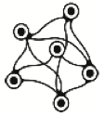
Complex: The outcomes and social changes relating to C4D projects are complex and often unpredictable. For this reason it is important to be flexible in designing and evaluating, and to stay attuned to unexpected things that occur, both positive and negative.

However well you plan your project and think about the positive changes you expect to see, there are always surprises - some you will welcome, and some will make you rethink your activities.

This kind of information may be missed by your main methods for collecting data, since those are tied closely to your plans and predetermined evaluation questions. Unexpected events often present useful opportunities to reflect, learn and improve your project.

Some practical ways to capture the unexpected are:
- Keep a diary or journal for your project and record your thoughts and observations. For interesting and unexpected things, make sure you record details such as when, where, who, how… and what you think the implications are for your project.
- Use a form to quickly fill in details of unexpected events as they arise. We have included an example in the appendix. It’s a good idea to print off the forms and have them handy.

These can be reviewed in project meetings and/or through evaluation activities. This is discussed in more detail in the next module.

Unexpected Event Tracking Tool: (you can adapt this to suit your project)
Date:

Unusual Event description:

Implications for your project (if any):

Recommended adjustments to your project or activities (if any):

Reported by:
Contact person for follow up:

Module 8: Making sense of data
This module offers a guide through the processes of managing and analysing data. Analysing data can be a big job so we recommend you do this as you go, and don’t wait until the end to analyse all the data. Analysis is about looking for patterns. You can also feed your findings into your ongoing activities, adjusting your activities based on what you are finding.

You may also consider involving some of your stakeholders in this process. Look again at your stakeholder map and consider which groups could help you make sense of the data.

Manage Data
It is very important to keep good records of all your data. Below is an example of a label template for individual and group data. It makes sure you have easy access to the name (or basic demographics e.g. male/female), date, where it was collected, the type of data (or methods used to collect the data) and a summary.

Individual:
Date
Data type
Location
Name
Role or position
Gender
Age
Summary and comments

Group:
Date
Data type
Location
Title of activity
Number of participants
Summary and comments

Discussion Exercise
- Who in your team will be responsible for labeling and storing the data? Where will you keep the data?
- What kinds of information (age, date of collection, m/f, demographics) will you need to collect about the participants in your data collection?
- What forms of labeling will you need? Think about a system for file names for digital information, a spreadsheet or table, or use a folder to collect this.
- If you do qualitative data collection (like interviews and observation notes), it can be a good idea to write a summary immediately after the data is collected for quick reference. You can use or adapt the worksheets below.
- How will you make back-up copies of the data in case of damage or loss to original? Where will back ups be stored? Who will be responsible?

Analysing data
When talking about analyzing data it is helpful to understand that there are two general kinds of data: quantitative (based on numbers) and qualitative (based on words, stories and images). Below are some of the types of patterns you can look for in quantitative and qualitative data, and then a group exercise to help you and your team look at the data with these kinds of questions in mind.

Quantitative data analysis (data based on numbers)
Any quantitative data you have, such as from short questionnaire surveys or rankings, can be analysed by looking for patterns in the numbers, for example:
- what are the main conclusions from your questionnaire or rankings across the different questions?
- are there differences in responses by age, gender, location?
- (if you repeated the questionnaire or workshop) What changes have there been in the responses over time?
- Does your data suggest ways in which your activities have made a difference to individuals and/or groups, either positive or negative?

Qualitative data analysis (data based on words and stories)
Qualitative data is often text, language or story- based, rather than based on numbers. The data can include a range of types of data such as your notes and observations, interview materials, group discussion materials, collected stories, photographs. As with quantitative data, the idea is to look for patterns.

- What are the main conclusions emerging from your qualitative data across your different questions?
- Are there any strong themes or issues emerging?
- Can you identify any differences across groups such as age groups, gender, location?
- Does your data suggest ways in which your activities have made a difference to individuals and/or groups, either positive or negative?

Your analysis of the data should allow you to explain and provide evidence for your answers to the questions above.

Group Exercise
Thinking about all of your data together - both qualitative and quantitative:

As a group discuss your answers to the questions above for both quantitative and qualitative data. Capture your main thoughts on this before going into the analysis in more detail:

- Write each of the of the following analysis questions on a piece of flip-chart paper.
  - What have been the most important changes? How do you know (what evidence, refer to your data)?
  - What things that are working well? How do you know (what evidence, refer to your data)?
  - What things are not working well? How do you know (what evidence, refer to your data)?
  - What things are unexpected?
- Write answers to the questions on sticky-notes, referring to the data (date, method, who involved) – you may write quotes, observations, insights or examples.
- Then, discuss what you think are the main ideas or themes emerging from across all of your data. You can do this by sorting the sticky-notes into groups of similar ideas.
- Summarise these main ideas or themes. These summaries can be included in your evaluation report.

After you have made sense of the data and have some findings, go back to your data-use plan (Module 5) as a reminder of the types of reports you planned to create using the data.

These modules are adapted from the BetterEvaluation.org ‘Rainbow Framework’, which is focused on evaluation.
Based on Lusthaus et al (1999) Stakeholder Assessment, Tool 2 p86, see http://betterevaluation.org/evaluation-options/mapping_stakeholders.
adapted from http://www.mc3edsupport.org/community/kb_files/evalquestions_worksheet5.pdf

